Time complexity

a star search time complexity, with manhattan heuristic

O(b^average solution depth)

MSA O(b^average solution depth) * O(N)

Find neighbor iteration

For every node, get distance, compare with the max distance.

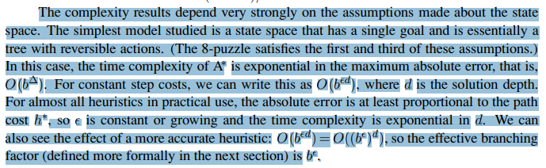

MSA*

Average search depth

Each iteration:

pseudocode

O(b^4)

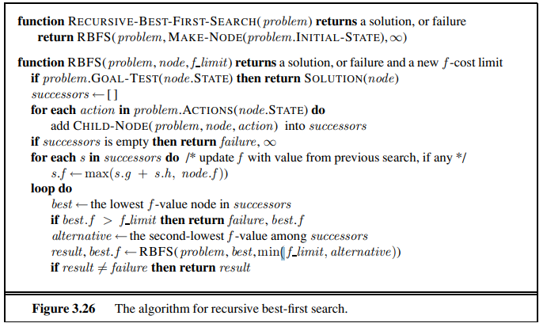

Since the neibor for each node is unknown.

(N*N*1)^4

Experience results:

1. Successful rate(static): 512*512

100 random initial position, 100 random target position

If a node stuck in position for couple time. The results will vary with different map

Open node: distance between node and the current position of the agent

$d < alpha*2^{9 - depth}$

Depth = 0 512*alpha

1 256*alpha

2 128*2

3 64*2

4 32*2

5 16*2

6 8*2 16

7 4*2 8

8 2*2 4

9 1*2

Drop node if Cr < 0.25

| alpha | beta | Average nodes | total Search time | Successful rate | Average total length  (forgot to record)with 0 |
| --- | --- | --- | --- | --- | --- |
| 2 | 0.25 | 215.82 | 4669 | 0.97 | 456.8 |
| 2 | 0.5 | 210.66 | 4225 | 0.97 | 456.8 |
| 2 | 0.75 | 205.4 | 3563 | 0.79 | 463.71 |
| 2.5 | 0.25 | 457.31 | 2.48 | 38.23 |  |
| 2.5 | 0.5 | 1322.34 | 34.21 | 100 |  |
| 2.5 | 0.75 | 1451.21 | 43.17 | 100 |  |
| 1.5 | 0.25 | 839.2 | 21.39 | 40.21 |  |
| 1.5 | 0.5 | 131.32 | 1959 | 0.97 | 468.74 |
| 1.5 | 0.75 | 128 | 1780 | 0.85 | 397.81 |
| A* | A* | N/A |  |  |  |

1. Dynamic environment with re-planning (single agent) step by step, weather will block random spaces

|  | Total length(flying time)(512/1024 /2048) | Total search time(512/1024 /2048) | Search time + flying time(512/1024 /2048) |
| --- | --- | --- | --- |
| A star |  |  |  |
| MRAstar(alpha = 2, beta = 0.5) |  |  |  |

3: Multi-agent use cases, A star reserve whole traj, MSA* do dynamic reservation.

|  | Total flying time(512/1024 /2048) | Total searching time(512/1024 /2048) |
| --- | --- | --- |
| A star |  |  |
| MSA* |  |  |

finding Neibor

if neibor is 1 level higher than current node

if neibor is 2 level higher than current node

if neibor is same level

if neibor is 1 level lower than current node

if neibor is 2 level lower than current node